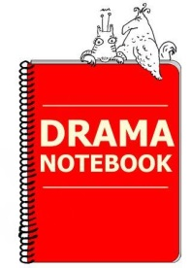

Purchase Order Information Form

Date:

Name of teacher:

Teacher’s email:

Preferred username:

Name of school:

Name of person handling payment:

Address of school or district:

Paying by check or debit card: (indicate one)

If paying by check, also include:

Email of person handling payment:

Timeline of when check will arrive:

Do you need a detailed receipt?

If yes, please include:

Email of person needing the receipt:

Date payment was made:
(Receipts may only be issued after payment.)

Drama Notebook Info

Make Checks payable to:
Drama Notebook
2620 S. Kinney Rd., Tucson, Arizona 85735

janea@dramanotebook.com
Phone: 520-301-3718 (no fax number available)
EIN# 46-0603546

