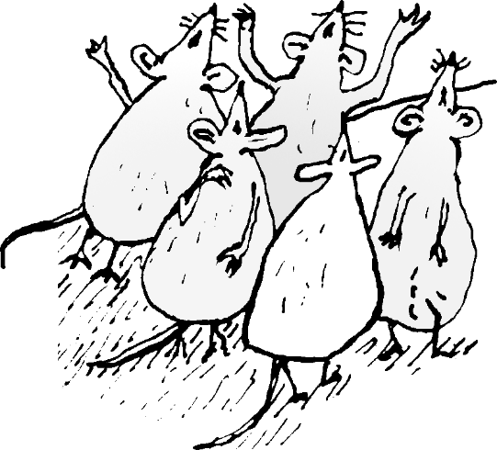

Greetings playwrights!

Below are all of the elements of a fully formatted script. You are not obligated to use this template, but if you have time to send your script to us in this format, it will be greatly appreciated. Many elements are the same for each script, but some things need to be customized. These are all highlighted for you.

No worries if you are not able to do it. Our small team will do it for you if we choose to put your play up on Drama Notebook.

We do ask that you send us a clean copy of your script (free of tables, and columns, etc.) with the following guidelines:

In WORD, set margins to .5 inch top and bottom. 1.0 inch left and right.

Line spacing=0 before and after. Single spacing.
Font=Tahoma 11 pt. for text of play
SF Grunge Sans for headings, titles, etc.
SF Grunge Sans can be downloaded here.

Footer=Austin with Drama Notebook, www.dramanotebook.com,
the name of the play and page numbers.

Please do not insert page breaks, columns, or tables.

Thank you!

Copyright 2018
ALL RIGHTS RESERVED
Reproduction without written permission prohibited.

No part of this script may be reproduced, stored or introduced into a retrieval system or transmitted in any form, or by any means (electronic, mechanical, photocopying, recording or otherwise) without the express written permission of both the copyright owner and the publisher of this script. Permission to present the work in the classroom (or other venues) is limited to live performance, which may not be recorded and absolutely may not be distributed, for free or for sale, to anyone, without the publisher's/playwright's express written permission.

This script is authorized for individual sale and use only, unless a group license is granted. Please contact the publisher to obtain group licenses for use in after-school organizations, school districts, theatre companies, etc.

The scanning, uploading and distribution of this script via the internet or via any other means without prior permission of the publisher is illegal and punishable by law.
Your support of the author’s rights is appreciated.

Inquiries, contact alex@dramanotebook.com

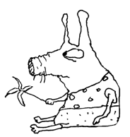
About the Author…
This is where the bio goes.

Thank the Author…
Do you love this play as much as we do? If your group performs this piece, be sure to credit [playwright] and Drama Notebook in your program and advertising. You may also wish to make [playwright’s] day by dropping him/her a line or sending pictures of your production!

Contact [playwright] at: [email]

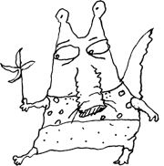
About the play…

This is where a blurb about the play goes. It can include details about why the play was written, for whom, whether is has been performed and where. It can also include study questions or information on any learning that can take place in conjunction with performing the piece. Examples of bios and ‘About the Play’ are at the end of this template.

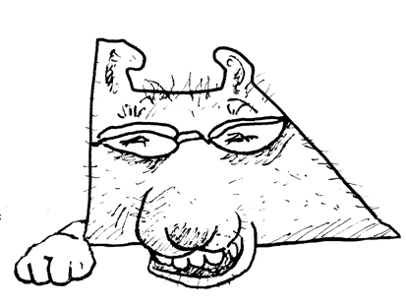

Performance Royalties…

If you perform this play in front of an audience, in lieu of royalties, we ask that you provide a link to the author’s website and to Drama Notebook on your school or theatre organization website.

Please send a note to Alex at Drama Notebook alex@dramanotebook.com with a link to the page where you are announcing the play and linking to the author and Drama Notebook.

Examples of what to say:
(Please copy the embedded links included with the text.)

[Name of play] by [playwright], is part of the royalty-free collection of scripts found on Drama Notebook.

This royalty-free play by [playwright] is part of a fantastic collection of plays for kids and teens on Drama Notebook.

Below is a formatted script page.

In WORD, set margins to .5 inch top and bottom. 1.0 inch left and right.

Line spacing=0 before and after. Single spacing.
Font=Tahoma 11 pt. for text of play
SF Grunge Sans for headings, titles, etc.
SF Grunge Sans can be downloaded here.

Footer=Austin with Drama Notebook, www.dramanotebook.com,
the name of the play and page numbers.

Please do not insert page breaks, columns, or tables.

Name of Play
Short description of play
by [Playwright]

CHARACTERS:

FIRST CHARACTER – description
SECOND CHARACTER - description
THIRD CHARACTER - description
FOURTH CHARACTER - description
FIFTH CHARACTER - description

TIME: [optional time of day, time period or era]

SETTING: Short description of setting.

FIRST CHARACTER:
Dialogue.

SECOND CHARACTER:
Dialogue.

FIRST CHARACTER:
Dialogue.

(Stage direction. CHARACTERS all caps.)

SECOND CHARACTER:
Dialogue.

FIRST CHARACTER:
Dialogue.

SECOND CHARACTER:
Dialogue.

FIRST CHARACTER:
Dialogue.

(Stage direction. CHARACTERS all caps.)

More plays by [playwright]…
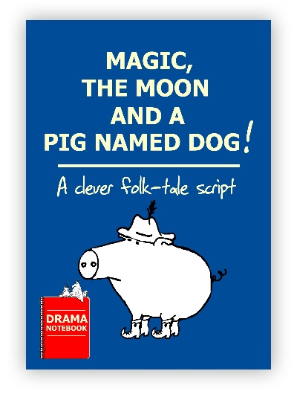
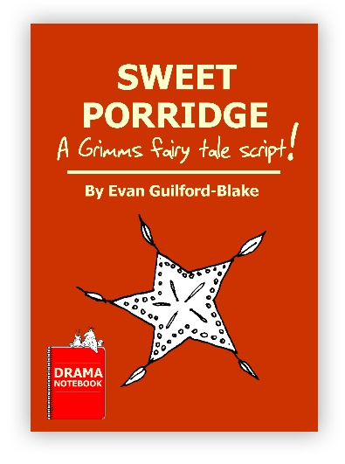
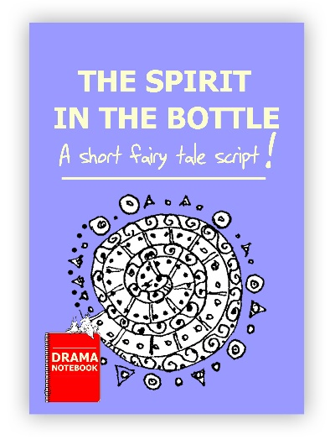

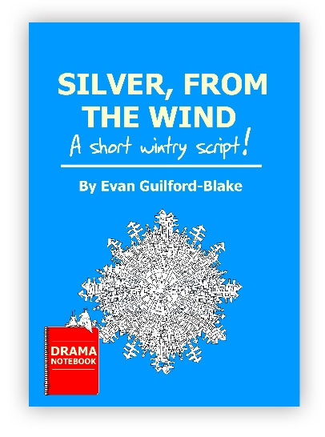
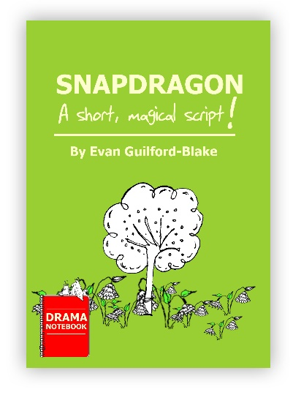

Examples of Playwright Bios

70-150 words. Include relevant theatre experience, any awards,
your website, and any personal information you wish to share.

Evan Guilford-Blake’s prose, poetry and plays have appeared in about 85 journals and anthologies, winning 27 awards and garnering three Pushcart Prize nominations. His novels "Animation" and "The Bluebird Prince," and the award-winning story collection "American Blues," are available through most e-retailers. His plays have been performed internationally and won 45 playwriting competitions. Thirty-three are published. His award-winning children's plays are published by YouthPLAYS, Eldridge, Pioneer Drama Service and Blue Moon Plays, among others. Please contact him for more information about them, or his extensive catalogue of works for adult audiences. Evan and his wife (and inspiration) Roxanna, a business writer and jewelry designer, live in the southeastern US. Find out more by visiting his Amazon author's page.

Hayley Cotton is a full-time performing arts instructor for The Homeschool Connection, a homeschool enrichment program in the Greater Denver Area. She holds a BA in Theatre Arts from the University of Wisconsin-Parkside and will obtain her MA in Theatre Education from the University of Northern Colorado in the Winter of 2018. She has been an actor since elementary school and a writer for as long as she can remember. In her free time, she is an avid rock climber and hiker!

Andy Pavey is a commissioned playwright, who writes short plays for Drama Notebook. He is a student who attends UWC-USA. He previously spent nine years with Davenport Junior Theatre, the second-oldest children’s theatre in the United States, where he acted in productions, managed the props building, and wrote plays for young actors to perform. In addition to writing, Andy is an avid backpacker!

Corinna Rezzelle is excited to join the writers of Drama Notebook! Corinna has been an active actor, director, and stage manager since childhood and a theatre teacher for almost eight years. Holding a M.A. in Educational Theatre and a teaching credential, Corinna’s goal is to create engaging theatrical scripts that all students will enjoy performing.

Examples of ‘About the Play’

This can be a synopsis, or who the play was written for, and when and where
the play has been performed. It can also be a brief study-guide
with discussion questions.

In this fractured fairytale, the Evil Queen (named Melissa) is determined to make herself the fairest in the land by getting rid of Snow White. Unfortunately for her, the Evil Princess she’s training doesn’t quite grasp what it means to be truly evil. With tons of disguises and mishaps, this story brings Snow White and Aladdin together to create a brand-new fairytale. This script has tons of fun and silly characters making a great option to help young actors create specific characters, memorize lines, or simply get used to handling a script.

…………………………………………………….

SnapDragon is about wanting to be accepted for who and what you are. Ochimber is an unusually beautiful Dragon, but loses his fire breath, a Dragon’s most critical asset, en route to the frozen land of Wintric. How, with the help of Névé, a talented and clever Fairy, he becomes useful again and able to be appreciated by the people of Wintric is a warm lesson in the value of acceptance. The story version won the 2014 Carteret (NJ) Writers Children’s Story Contest. Audience interactive.

…………………………………………………….

The Tale of Peter Rabbit is a British children's book written and illustrated by Beatrix Potter that follows mischievous and disobedient young Peter Rabbit as he is chased about the garden of Mr. McGregor. He escapes and returns home to his mother, who puts him to bed after dosing him with chamomile tea. The tale was written for five-year-old Noel Moore, son of Potter's former governess Annie Carter Moore, in 1893. The book was a success, and multiple reprints were issued in the years immediately following its debut. It has been translated into 36 languages, and with 45 million copies sold it is one of the best-selling books of all time.

…………………………………………………….

The Tortoise and the Hare is an Aesop’s fable in which an arrogant rabbit loses a race to a slow-moving tortoise. The hare feels so confident that he will win, that he takes a nap, allowing the tortoise to cross the finish line while he slumbers. The story has been used to teach the virtues of working steadily over time rather than acting in haste. Kids will love this humorous re-telling of the classic fable.

Read the original tale to your group before introducing the script.

Ask!
What is the difference between the two stories?
Why do you think the author added characters and changed the story somewhat? (To make the story more entertaining for the stage.)
What is the moral of the story? Do you agree with the lesson that the story is trying to teach? Why? Why not?

