A close up of an animal

Description generated with very high confidence

**Greetings playwrights!**

Below are all of the elements of a fully formatted script. You are not obligated to use this template, but if you have time to send your script to us in this format, it will be greatly appreciated. Many elements are the same for each script, but some things need to be customized. These are all highlighted for you.

No worries if you are not able to do it. Our small team will do it for you if we choose to put your play up on Drama Notebook.

We do ask that you send us a clean copy of your script (free of tables, and columns, etc.) with the following guidelines:

**In WORD, set margins to .5 inch top and bottom. 1.0 inch left and right.**

**Line spacing=0 before and after. Single spacing.**

**Font=Tahoma 11 pt. for text of play**

**SF Grunge Sans for headings, titles, etc.**

**SF Grunge Sans can be downloaded** [**here**](https://www.dafont.com/sf-grunge-sans.font)**.**

**Footer=Austin with Drama Notebook,** [**www.dramanotebook.com**](http://www.dramanotebook.com)**,**

**the name of the play and page numbers.**

**Please do not insert page breaks, columns, or tables.**

**Thank you!**

**IMPORTANT COPYRIGHT NOTICE**

Published in the United States by Drama Notebook [www.dramanotebook.com](http://www.dramanotebook.com/) a division of

Rumpelstiltskin Press, Portland Oregon USA

**All rights reserved.**

This script may be copied by teachers for use with their students. It may be shared via email and in Google Docs. It cannot be reproduced online on a publicly viewable website. It also cannot be re-sold or shared with other teachers.

**Please contact** [**Drama Notebook**](https://www.dramanotebook.com/contact/) **to obtain group licenses for use by multiple teachers or widespread use in after-school organizations, school districts, theatre companies, etc.**

Your support of the author’s rights is appreciated.

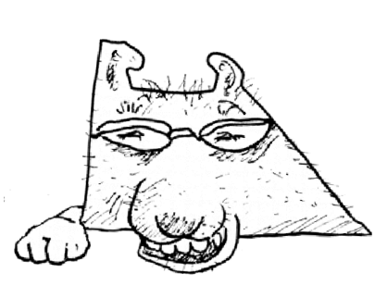

Licensing and Copyright Rules

1. **Thank the playwright.**

If you perform one of our plays in front of an audience, either in-person or virtually, you must contact Willow Rowe and let her know that you are performing her play! Her email is: willow.carrie.rowe@gmail.com

1. **Link to Drama Notebook.**

Post a link to the Drama Notebook Script Library <https://www.dramanotebook.com/plays-for-kids/>

anywhere on your school or organization's website.

1. **Share your photos.**

Send us photos, if you can to [alex@dramanotebook.com](mailto:alex@dramanotebook.com)

Click [here](https://www.dramanotebook.com/plays-for-kids/how-it-works/) for more information on our copyright guidelines.

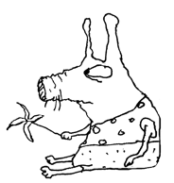

About the Author…

**Willow Rowe** has been a proud member of the theater community for ten years now! When she first started she was an actress but soon she learned that her true passion lay in playwriting thus beginning a journey of writing and creating plays for all ages, especially plays based on her favorite thing in the whole world, fairytales!

**Credit Willow Rowe and Drama Notebook in your program and advertising.**

**You must also write Willow to let her know that you are using her play!**

**Contact Willow Rowe at: willow.carrie.rowe@gmail.com**

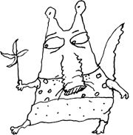About the play…

Peter Pan and Little Red Riding Hood collide in this incredibly imaginative tale. When Little Red finds herself in the world of Neverland, she is determined to join Peter Pan and his gang of lost boys. But first, she must prove herself by stealing Captain Hook's golden hook! Join Little Red on her quest to unite with the lost boys and save the day! A perfect story of adventure, girl power, and kindness for kids of all ages.

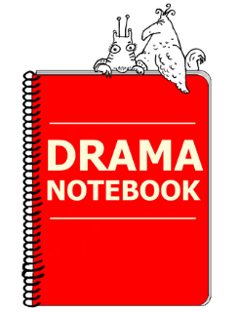

Name of the Play

**By (Playwright)**

**CHARACTERS:**

**CHARACTER NAME**–Description

**CHARACTER NAME**–Description

**CHARACTER NAME**–Description

**CHARACTER NAME**–Description

**CHARACTER NAME**–Description

**CHARACTER NAME**–Description

**CHARACTER NAME**–Description

**CHARACTER NAME**–Description

**SETTING**: Setting Description

Name of the Play

*(Scene setting description.)*

**CHARACTER NAME:** Dialogue

*(Action)*

**CHARACTER NAME:** Dialogue

**CHARACTER NAME:** Dialogue

**CHARACTER NAME:** Dialogue

**CHARACTER NAME:** Dialogue

**CHARACTER NAME:** Dialogue

**CHARACTER NAME:** Dialogue

**CHARACTER NAME:** Dialogue

*(Action)*

**CHARACTER NAME:** Dialogue

**CHARACTER NAME:** Dialogue

**CHARACTER NAME:** Dialogue

**CHARACTER NAME:** Dialogue

**CHARACTER NAME:** Dialogue

**CHARACTER NAME:** Dialogue

**CURTAIN**

Need another script?



Have a play to share?

